Problem 1 Output: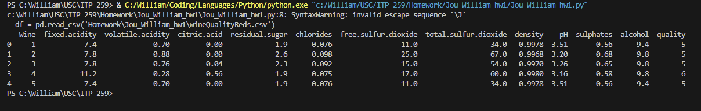

Problem 2 Output: 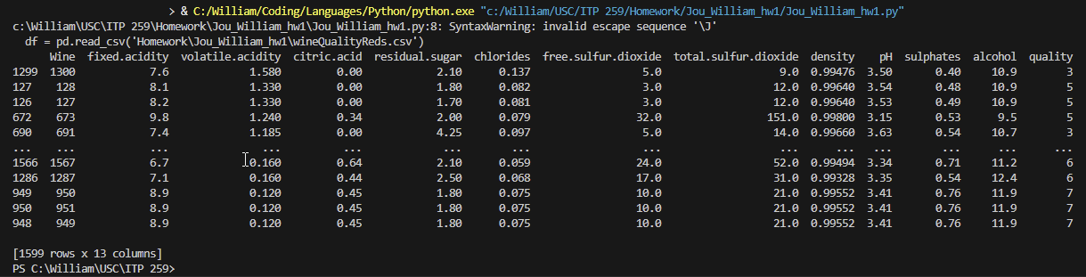

Problem 4 Output: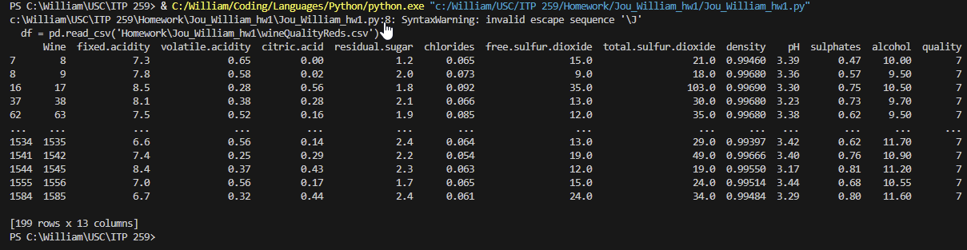

Problem 5 Output: 

Problem 6 Output: 

Problem 8 Output: 

Problem 9 Output: 

Problem 10 Output: 